

UNIVERSITY OF ENGINERIING AND TECHNOLOGY, LAHORE

Project Title
Online Cab Services: Data Report and Analysis
Course: Applications of Information and Communication Technology Lab (AICTL)
Instructor: Ms. Ramsha Khalid
Submitted By:
Muntaha Rizwan – Roll No. 2025, GA, 45
Qiraat Tahir – Roll No. 2025, GA, 50
Ayesha Fayaaz – Roll No. 2025, GA, 21
M.Daud Butt – Roll No. 2025, GA, 38
Umair Abu Bakar – Roll no. 2025, GA, 04

Section: Gaming and Animation(A)
Submission Date:

Contents
Summary: 3
Research objectives and scope: 3
Specific Research Objectives: 4
Scope of study: 4
Data summary and Observations: 4
Gender Distribution of Respondents: 5
Usage of Popular Cab Companies by Gender: 5
Waiting Time with Respect to Gender: 6
Awareness and Perception of Safety: 7
Willingness to Use Online Cab Services in the Future: 7
Preferred Mode of Payment: 7
Summary of Observations 8
Findings and Discussion: 8
Conclusion: 9

Summary:
Over the past decade, online cab services have transformed urban travel worldwide, Pakistan included, making it as easy as tapping a phone screen to call a ride through the evening traffic. App based services like Careem, Uber, and InDriver have changed the way people get around, letting anyone tap a phone screen and book a ride in seconds. Now, instead of standing on a curb for a cab or squeezing onto a crowded bus, people can tap their phones a few times, watch the little car icon glide closer on the map, and get where they’re going quickly and safely.
Online cab services have surged alongside Pakistan’s digital transformation and the quick spread of smartphones, glowing screens lighting up almost every street corner. As internet access grows and data plans get cheaper, people are leaving traditional transport behind and turning to tech, driven options, rides you book with a tap and a quick buzz of your phone. These platforms bring together convenience, flexibility, and easy access, especially in crowded cities like Lahore, Karachi, and Islamabad, where long lines of honking cars and scarce transport options slow everyone down. Online cab services run on a digital marketplace, linking riders straight to registered drivers, like tapping a screen to see a nearby car icon slide across the map. You can pick the kind of ride you want, economy, business, bike, or car, see your driver’s route as it unfolds, check the fare before you go, and pay in cash or with a quick tap on your phone. For drivers, these services have opened new job options and flexible hours, like picking up rides between morning coffee and school drop, offs, adding fresh energy to the gig economy. Still, as more people lean on these services, worries keep surfacing, about safety, rising costs, and whether they’ll show up when the rain starts. Many passengers, mostly women, say they feel uneasy about safety, the way some drivers act, and how no one really checks their identities before a ride. Surge pricing, spotty ride availability, and limited payment options all chip away at user satisfaction, leaving riders frustrated when they can’t hail a car on a rainy night. This report examines how people in Pakistan, especially those in busy city centres, use and view online cab services. It looks at who the users are, what services they prefer, how long they wait, how they pay, and how safe they feel, like noting a line that stretches past the door at noon. These findings come from primary data gathered through a Google Form survey of 58 people, then broken down into colourful charts and clear, simple graphs. This study aims to shed light on the latest trends and hurdles facing online ride, hailing platforms, explore what users experience, from long waits to seamless trips, and offer clear, practical ways to improve how these services are delivered. By studying how men and women use apps, what makes them happy with each ride, and how they behave online, this report shows how cab services are reshaping Pakistan’s everyday travel and pushing cities toward cleaner, more sustainable transport.

Research objectives and scope:
This study looks at how city commuters use online cab services, their habits, opinions, and the hurdles they run into, like waiting on a rainy corner for a driver who’s stuck in traffic. As digital ride, hailing apps like Careem, Uber, and InDriver gain traction, it’s become crucial to understand how they shape people’s everyday travel habits, and what makes riders feel confident and satisfied, from a smooth pickup to a fair fare. This study seeks to deeply understand how people use ride, hailing services by looking at factors like gender differences, wait times, payment habits, safety worries, and whether riders plan to keep booking those online cabs down the road. The research looks at how these services make travel easier and more accessible, but it also digs into the obstacles, like patchy internet or confusing apps, that stop people from fully embracing digital transportation systems.

Specific Research Objectives:
- Find out who’s choosing online cab rides, their age, location, maybe even how often they tap that ride, hailing app after work.
- To study how often people use ride, hailing apps and why, comparing patterns between men and women, like who’s more likely to call a car on a rainy evening.
- We measure how satisfied users feel by looking at their wait time, what they pay, and how good the service is, like whether their order arrives warm and on time.
- To gauge how people feel about safety, comfort, and how much they trust their drivers, like noting if someone grips the seat when the car speeds up.
- We’ll look at which payment methods people prefer and the hurdles they face with digital transactions, like a failed tap at the checkout counter.
- We’ll explore which payment methods folks like and what gets in their way when going digital, say, that awkward moment when a card refuses to tap at the checkout.

Scope of study:
This study draws on a group of 58 respondents, mostly city residents, who filled out an online survey form. We’re zeroing in on how passengers use online cabs, the clicks, the wait times, the choices they make, not on how the companies run or manage their operations. The study looks at Pakistan’s top ride, hailing services, Careem, Uber, and InDriver, the main digital ways people catch a ride, from a quick tap on a phone screen to a car pulling up at the curb. The research centres on user experiences from 2024 to 2025, aiming to capture what’s happening now, the buzz, the habits, the trends, instead of predicting the distant market future. This report aims to help students, policymakers, transport planners, and service providers understand how online cab services can make city travel more sustainable, safer, and smoother, like turning a gridlocked street into a steady flow of lights.

Data summary and Observations:
This section shows what we found from the online survey, revealing how people use, prefer, and think about cab services, like which apps they open first when it starts to rain. We gathered data from 58 people and turned it into clear visual charts, showing who they are, how often they hail cabs, how long they wait, what safety worries them, and how they prefer to pay, like cash, card, or app swipe.

Gender Distribution of Respondents:
The survey showed that most respondents, about 67.2%, were women, while only 32.8% were men, a split as clear as two columns on a spreadsheet. This shows that women make up a large share of people using online cab services, nearly half the riders waiting at the curb might be them. More women are using ride, hailing apps, showing they’ve become a key travel choice for commuters who want the ease and sense of safety those rides offer, especially after dark, when buses can feel uncertain.
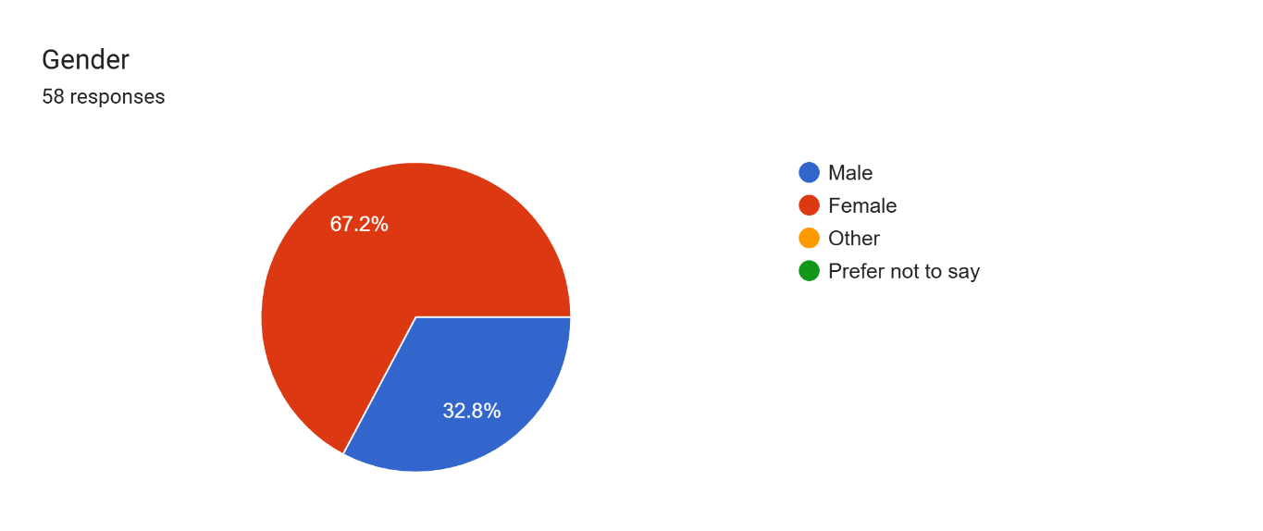
Figure 1: Gender Distribution

Usage of Popular Cab Companies by Gender:
The data showed that people used Careem and InDriver most often, with Uber trailing close behind. Women said they used these services more often than men, usually for daily commutes, riding to campus or heading to work with a quick stop for coffee along the way. Men said they use cabs only occasionally, usually when it’s a long trip across town or they’re heading home after midnight under flickering streetlights. This finding shows that gender shapes how often people hail rides and which company they’re drawn to, like choosing Lyft’s pink glow over Uber’s black cars.
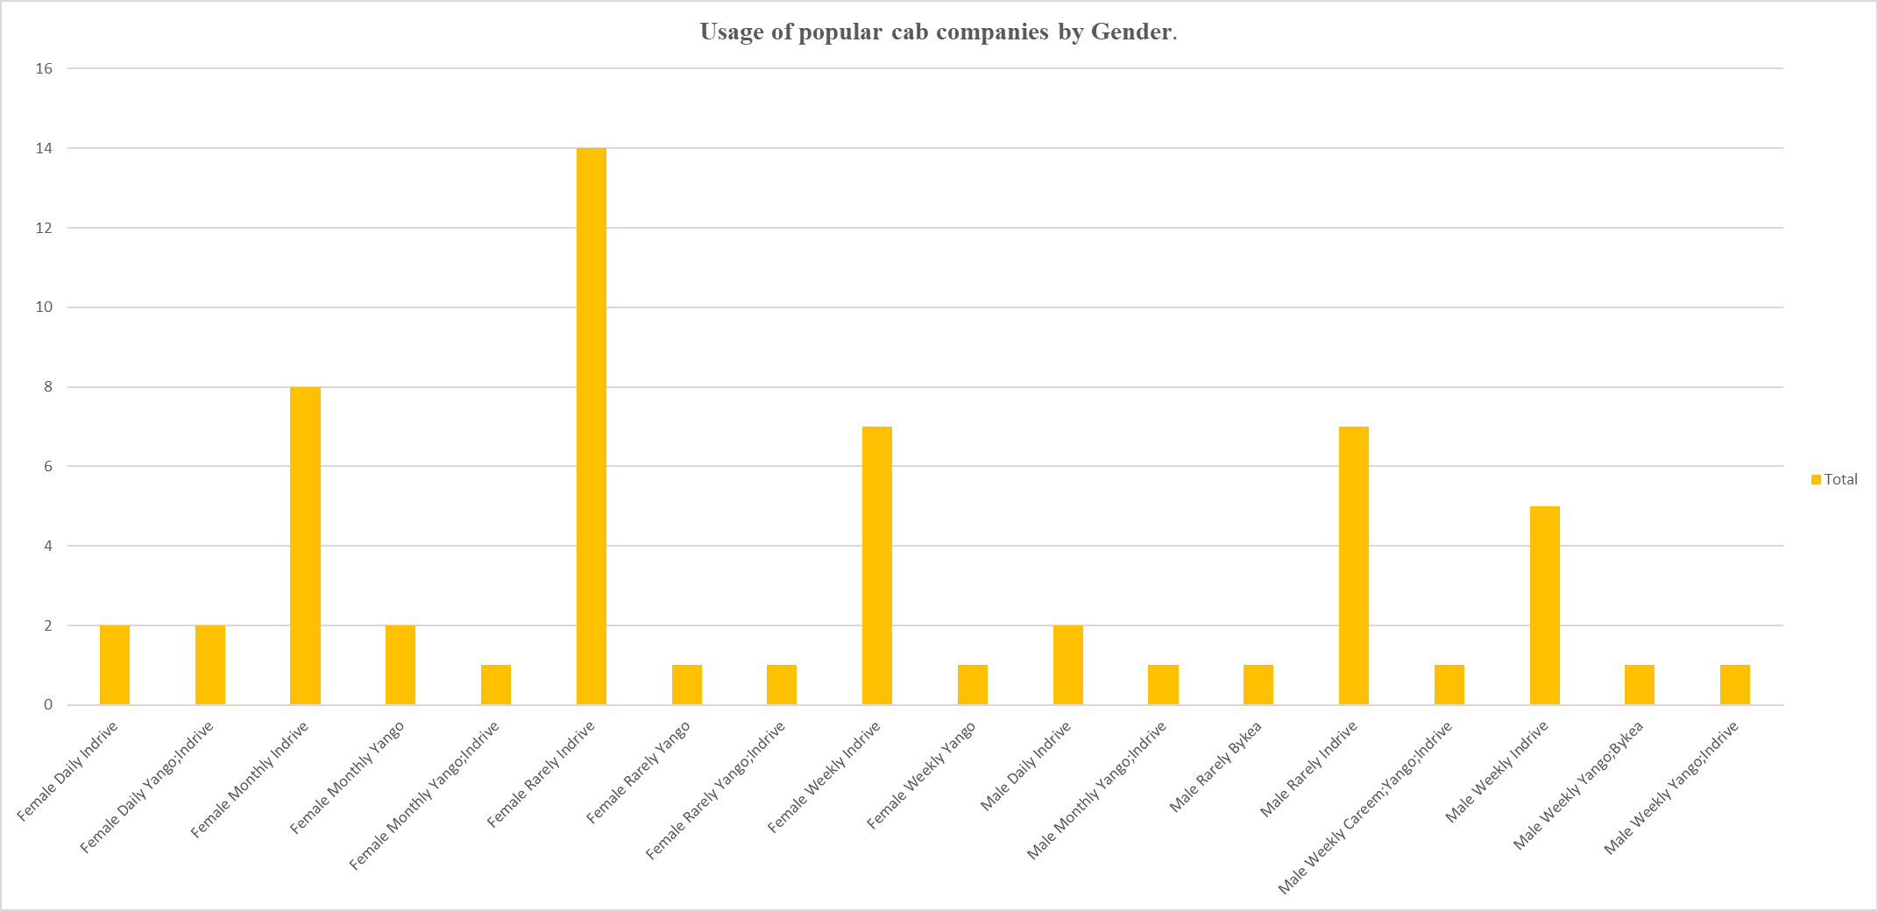
figure 2: Most Frequently Used App

Waiting Time with Respect to Gender:
Most users, especially women, said they usually waited about five to ten minutes, though a few men mentioned the line creeping past ten as the clock ticked. These differences might come from how many routes are open, how crowded the area is, and how often people need a ride, like the rush of requests when rain starts falling downtown. Overall, people didn’t wait long for rides, just a few minutes at most, which shows major cab platforms are covering the area well.
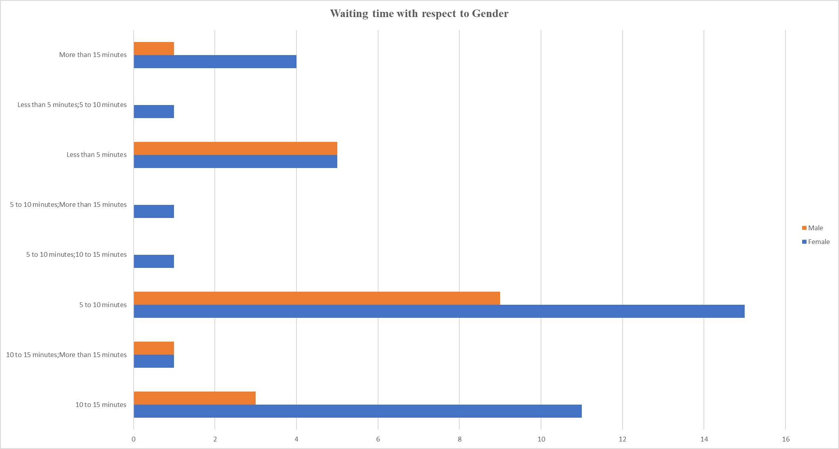
Figure 3: Average Waiting Time

Awareness and Perception of Safety:
When asked if they felt safe using online cab services, 62.1% said they had safety concerns; only 20.7% trusted the rides, and the rest stayed unsure, picturing dimly lit streets or unfamiliar drivers. People were mostly worried about how drivers acted, the risks of traveling after dark, and the slow, ineffective way complaints were handled. Even with online cab apps becoming more popular, riders still worry about trust and safety, concerns that service providers need to address right away, before another late, night trip goes wrong.
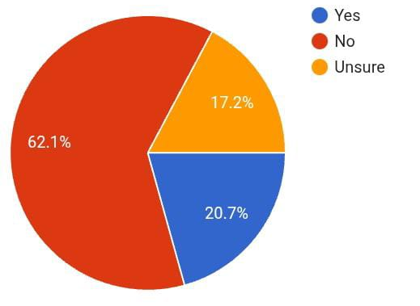
Figure 4: Safety Perception

Willingness to Use Online Cab Services in the Future:
Over half of the respondents, 51.7%, said they’d keep using online cab services, while about a quarter (25.9%) admitted their choice would hinge on price, like whether the fare spikes during rush hour. A smaller share hesitated or just couldn’t decide. These results reveal that people may love the ease of online cab services, but the fare, what it costs for a quick ride across town, still shapes whether they’ll stay loyal in the long run.

Preferred Mode of Payment:
The study found that cash still rules, about 91% of payments, while only a handful of people swipe cards or pay online, like tapping a phone at checkout. This pattern shows that digital payments haven’t caught on widely, and most people in Pakistan still prefer the feel of cash changing hands. It also underscores the importance of offering secure, easy, to, use, and dependable digital payment options, like a quick tap at the checkout, to help more people go cashless.
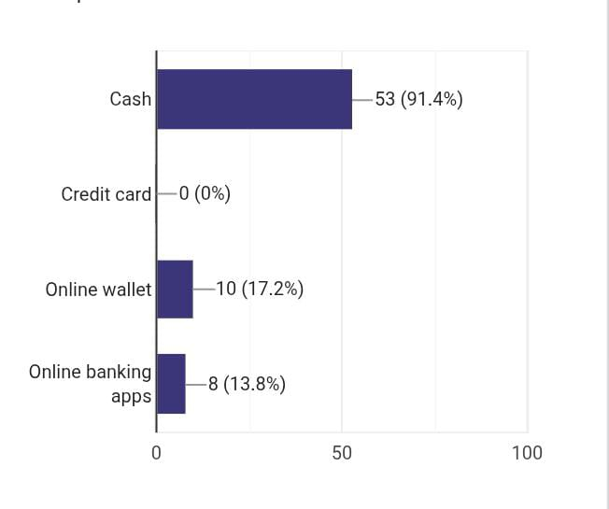
Figure 5: Payment Method Preference

Summary of Observations
- Women make up most of the people booking rides online, the majority tapping on their phones to call a cab.
- Careem and InDriver are the most preferred ride, hailing companies.
- The average waiting time for most users lies between 5 and 10 minutes.
- Safety concerns are widespread, particularly among female passengers.
- Cash remains the most trusted form of payment, with very low digital payment usage.

Findings and Discussion:
Studying the data paints a clear picture of how people in Pakistan use and view online cab services, the quick convenience, the frustration when a ride cancels, and the mix of promise and problems in this fast‑growing way to travel. The findings show that women make up most ride, hailing users, about 67%, suggesting they depend on these apps for everyday travel, whether it’s a quick ride to work or a late, night trip home. This reliance stems from the lack of safe, convenient public transport for women, so many turn to online cabs instead, they’re faster, more comfortable, and pick you up right at your doorstep. By contrast, men use these services less often, usually for particular trips, like catching a late, night ride home, heading to the airport, or when their own car’s out of reach. Out of all the ride, hailing apps, people used **Careem** and **InDriver** the most, those green and yellow icons popping up on nearly every phone screen. People value Careem for being reliable, on time, and thoroughly professional, while budget, minded riders lean toward InDriver for its fare negotiation feature, the chance to name a price and haggle with drivers right there in the app, like bargaining over fruit at a busy market. This gap in preference shows that customers choose based on price flexibility, convenience, and service quality, like picking the cab that’s easiest to book and doesn’t strain the wallet, so competition among companies mostly depends on how smoothly they blend affordability with customer comfort. The study found that most riders waited about five to ten minutes for a cab, just enough time to spot a bus rumbling past, suggesting that online ride services fit smoothly into city life and rides are usually easy to get without long delays. Still, a few respondents said they waited longer, possibly because fewer drivers were around during rush hour or on quiet roads outside town. These results show that overall service runs smoothly, but there’s still work to do, improving ride allocation and driver dispatch so every zone, from downtown’s busy corners to quiet outskirts, gets fair access. A key takeaway from the study centers on safety concerns, like how a single loose wire can trigger a serious hazard. About 62% of the people surveyed said they felt unsafe using online cab services, like when a ride took a dark, unfamiliar turn through backstreets. People reported problems like rude drivers, tense late, night rides, and slow responses when they tried to complain. This feedback highlights how urgently companies need to tighten their safety measures, checking driver backgrounds, adding in‑app emergency alerts, enabling live tracking, and giving drivers gender‑sensitive training that goes beyond a quick lecture. Building passenger safety and trust is vital if these services are going to last, especially for women, who need to feel secure, even on a quiet street at dusk. One striking finding was how much people still Favor cash, about 91.4%, reaching for bills and coins instead of tapping a phone or card. This trend shows people still don’t fully trust or understand online banking or digital wallets; some hesitate even to tap their phones at the checkout. Cash feels simple and familiar, the crinkle of bills in hand, but it shuts the door on loyalty perks, digital discounts, and clear fare tracking. By offering rewards, strengthening security, and designing payment screens that feel effortless, companies can modernize their systems and stay in step with global ride, hailing standards. Overall, the findings show that online cab services now play a crucial role in how Pakistan’s cities move, busy streets humming with their white sedans and yellow logos. They provide convenience and flexibility, opening doors to work, yet they still wrestle with safety concerns, steep costs, and the slow climb toward full digital adoption, like an app that freezes just when you need it most. People’s enthusiasm for using cab services shows how much they’ve come to rely on these platforms, yet a few uneasy voices, like complaints about long wait times, point to parts that still need fixing. To grow sustainably, companies must put user trust first, keep prices fair, and use smart, tech, driven safety tools so every ride feels safe, affordable, and open to all, right down to the hum of a well, tuned engine on a busy street.

Conclusion:
The study finds that online cab services now play a key role in Pakistan’s city travel, where a quick tap on a phone can summon a ride through the crowded streets. Apps like Careem, Uber, and InDriver have made commuting easier, more flexible, and within reach, like catching a ride with a quick tap on your phone before the rain starts. They’ve given people, especially women, a safer, more comfortable way to travel, and at the same time opened fresh job opportunities for drivers in the growing digital economy. The survey results show that most users are happy with how easy these services are to access and how quickly they’re delivered, usually just five to ten minutes of waiting, about the time it takes for a fresh cup of coffee, proof of solid coverage and strong demand. Still, even with those bright spots, the study points out a few stubborn hurdles, like slow loading times, that drag down overall user satisfaction. Safety topped the list of concerns, more than half the riders said they felt uneasy on trips because of reckless driving, a broken complaint system, and flimsy ID checks that left them gripping the seatbelt a little tighter. These findings reveal that even though the services run on digital systems, the human side and day‑to‑day safety still need a serious overhaul, like fixing a warning light that keeps blinking on a control panel. Pricing and affordability still shape how often people ride and whether they stick around, when fares climb past a few extra dollars, riders start to hesitate. Many passengers think ticket prices jump around too much, especially when rush, hour crowds fill the platforms or demand suddenly spikes. A major limitation was people still choosing cash, about 91.4%, a sign they don’t trust digital payments much, the feel of crisp bills still winning over screens. Cash deals are quick and straightforward, but they hide where the money goes and make it hard for businesses to tie in loyalty points or digital perks, like earning a free coffee after five purchases. When we make digital payments secure, easy to use, and reliable, people enjoy a smoother experience and get things done faster, like tapping a phone to pay and walking away without a second thought. Based on these findings, we’re putting forward several ways to boost the quality and trustworthiness of online cab services in Pakistan, like ensuring every ride feels as smooth as a freshly polished car door shutting behind you.

